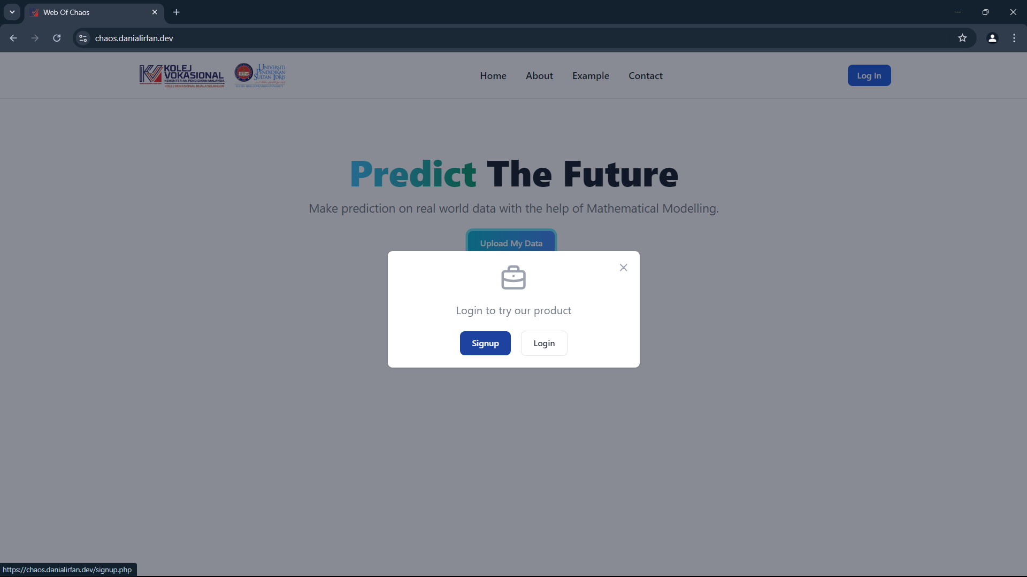

Users can log in if they already have an account

If the user does not have any account then the user can register as a new user

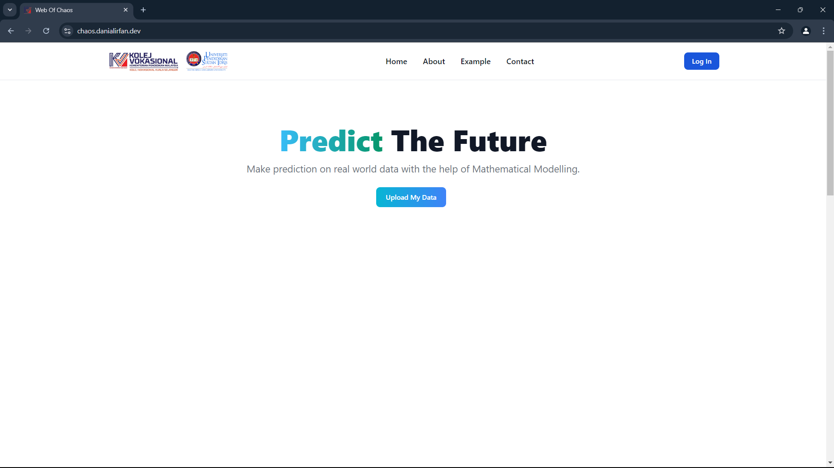

1. Click the login button

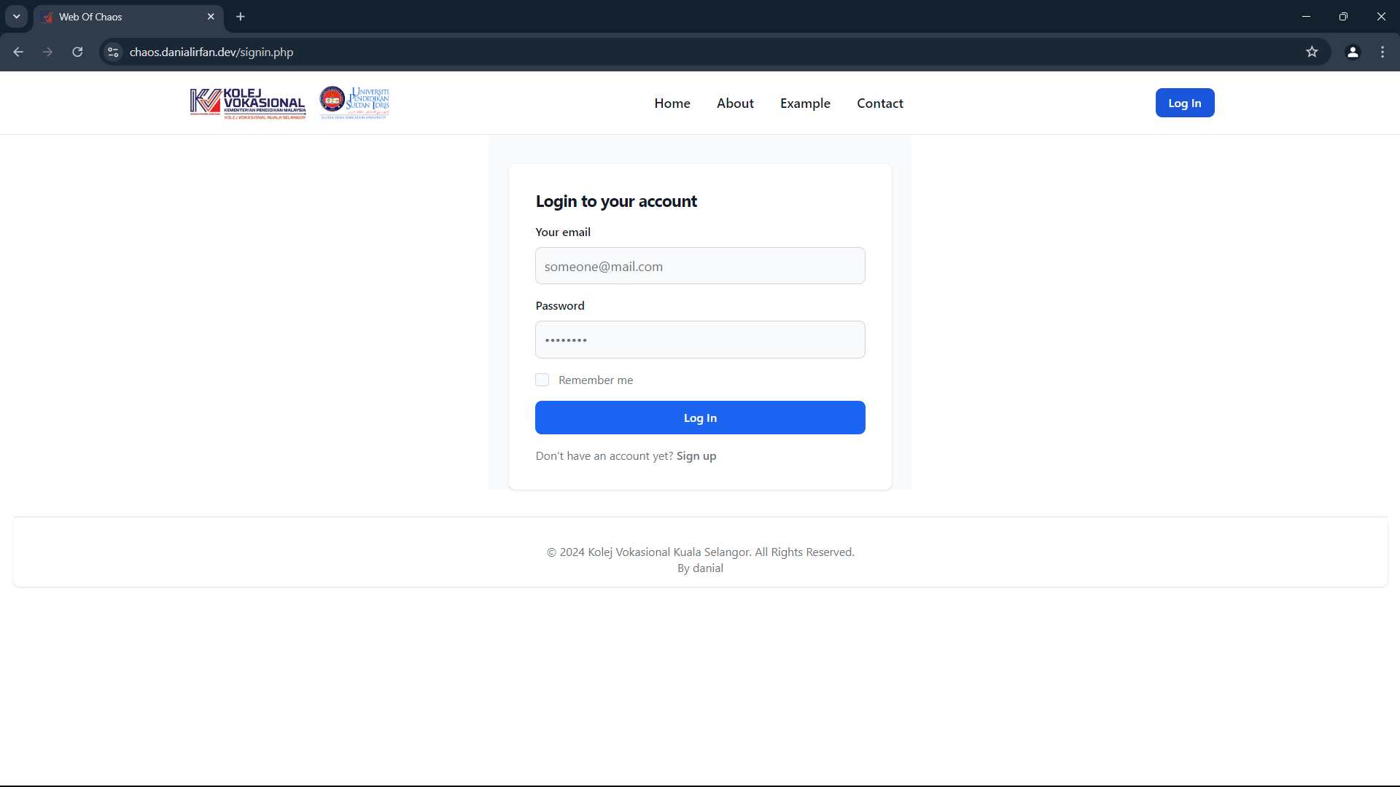

3. If you does not have any account then you can register as a new user

2. Insert your email and password

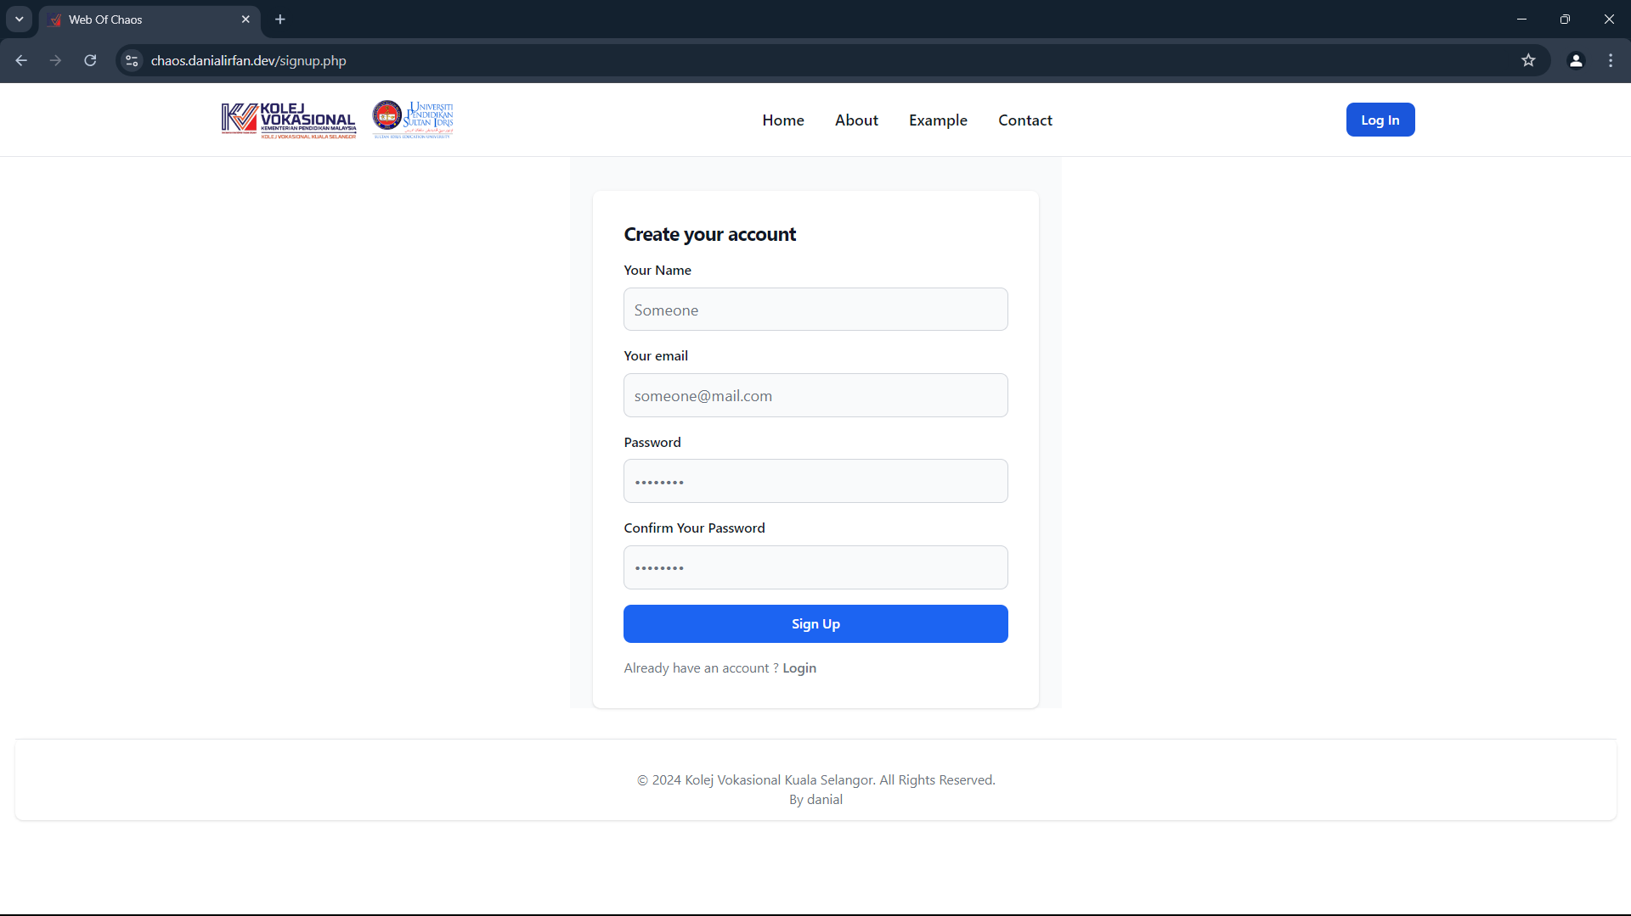

4. Fill the information needed to signup

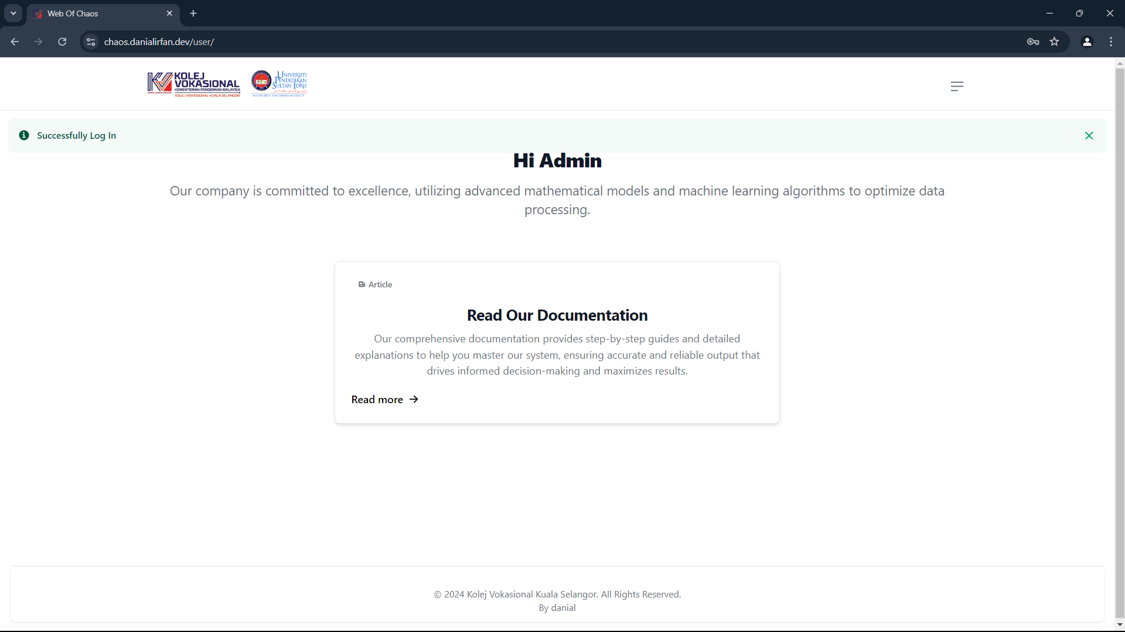

5. Click here to open the sidebar / navigation bar

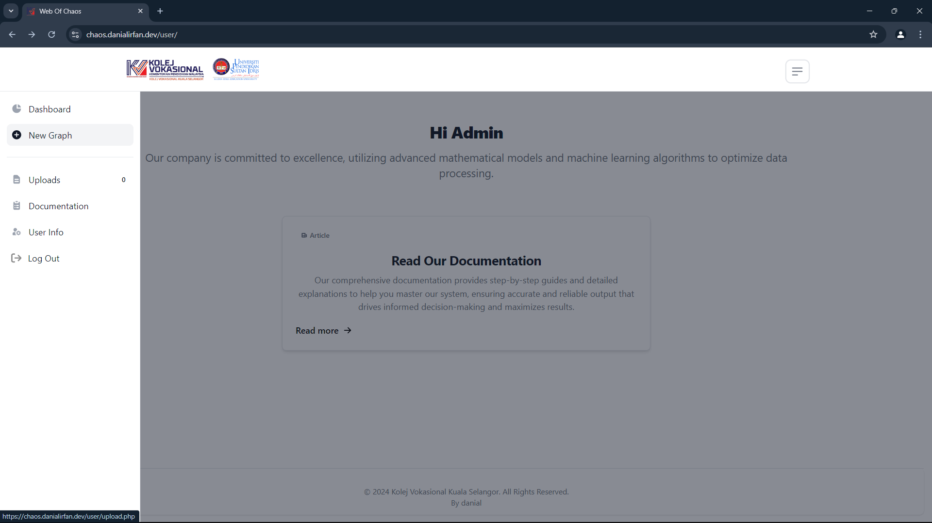

6. Click here to upload the data

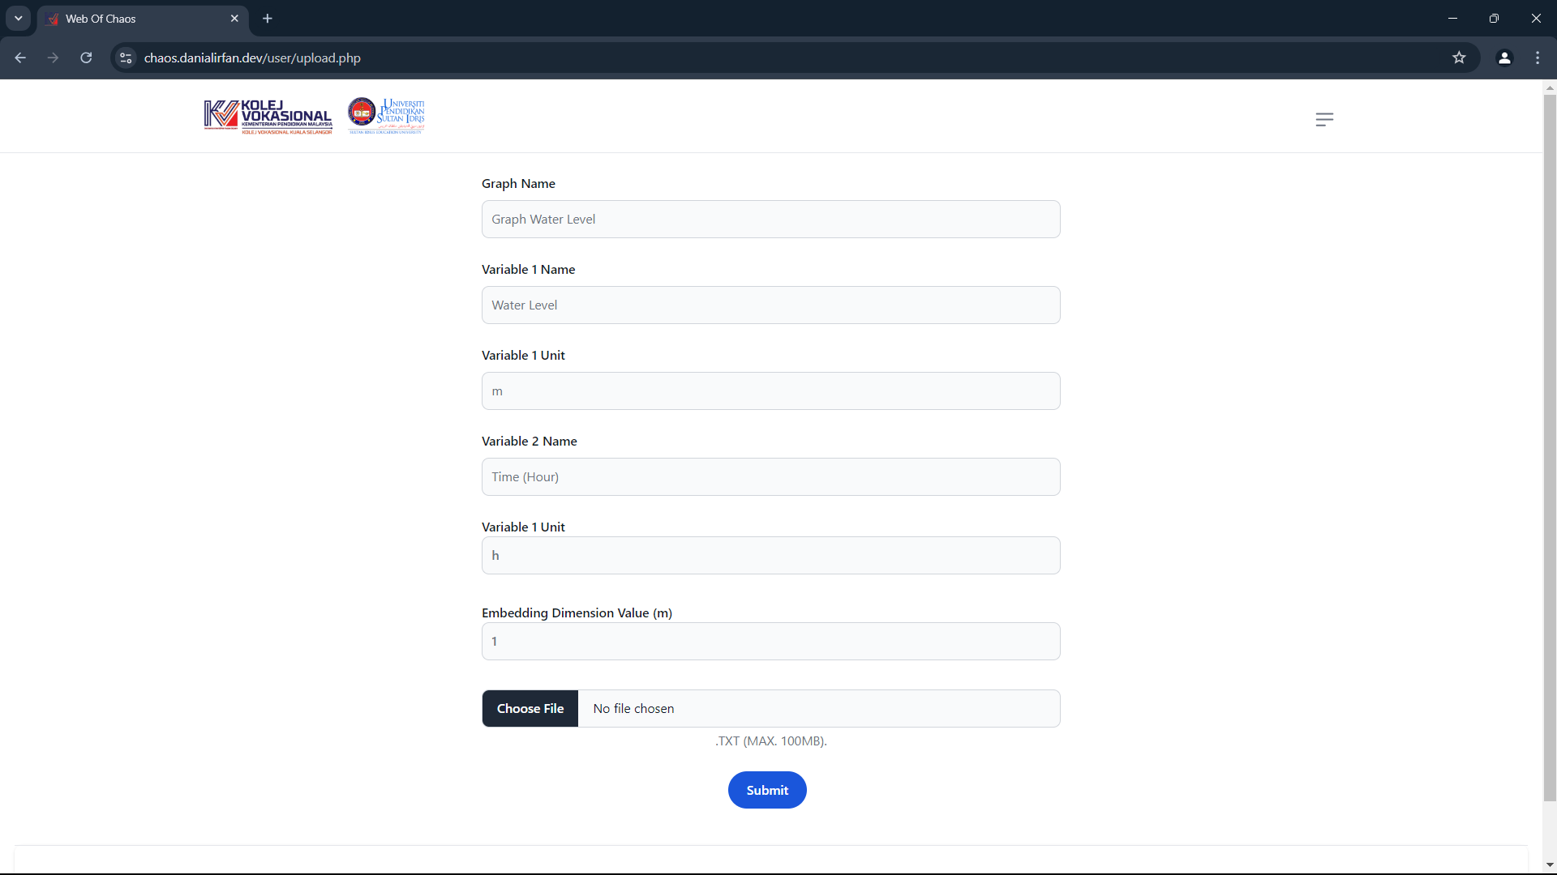

9. Click submit if the information was completed.

8. Enter the data file in CSV format

7. Insert the data information

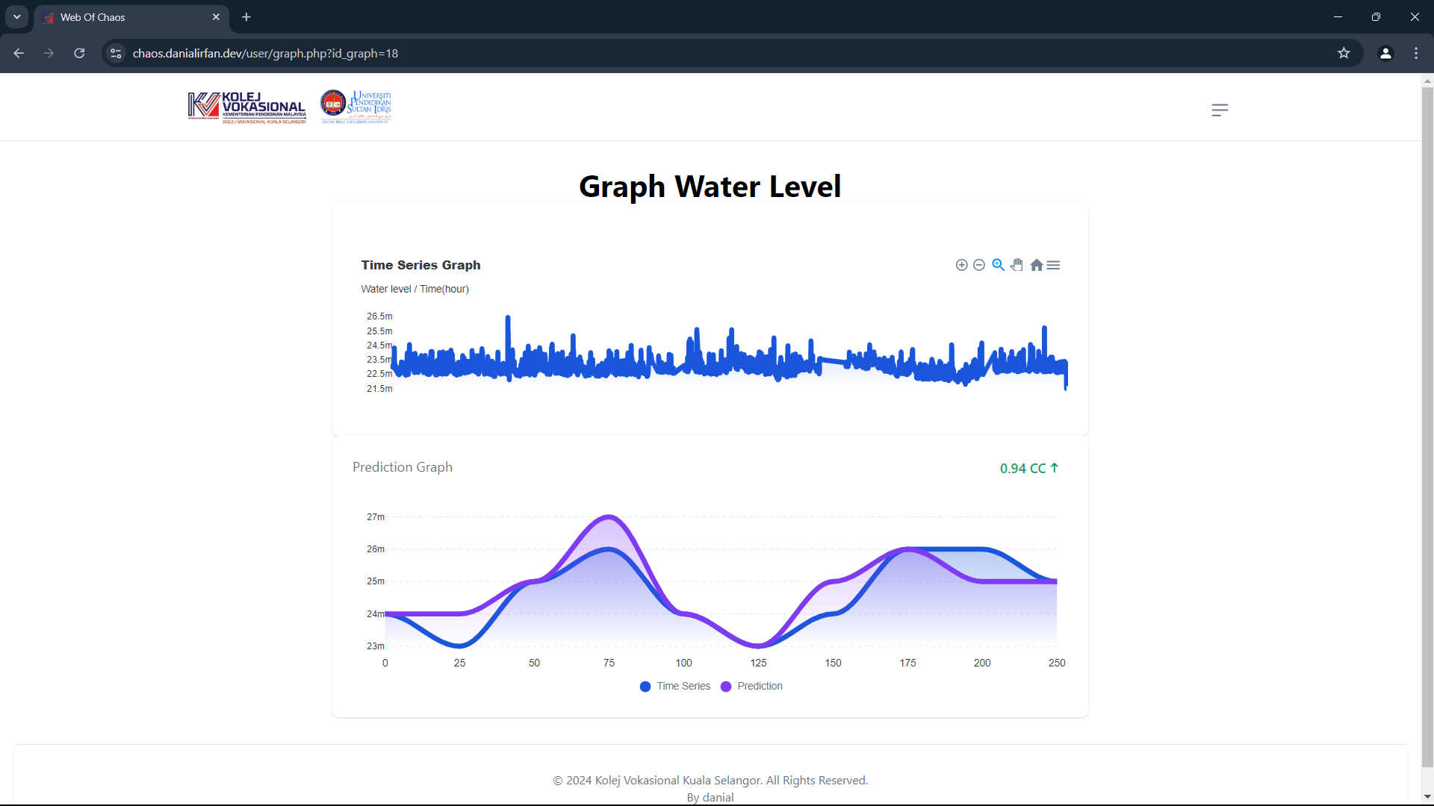

13. Click here to download the graph

12. This is a correlation coefficient or accuracy on graph prediction

11. The system will output the result of prediction graph

10. The system will output a timeseries graph

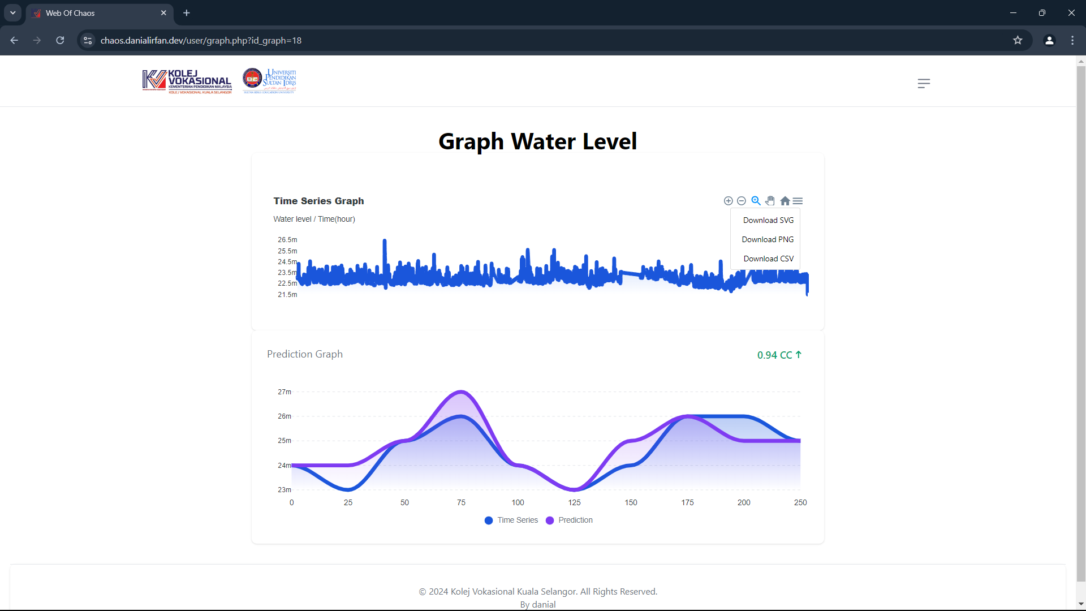

9. select a format to download the graph